## horizontal line

My Beloved Prabhuji

Starting this course with your blessings . You are always with me and what I learn should be for my and my Nation’s welfare , you have always encouraged me for that. Great regards. Thanks to you always…

Deep learning

02.01.2025

**─**

Vaishnavi

B.Voc.Software Development

Ramanujan College

Delhi University

# Deep Learning

Deep learning is a subfield of AI and ML .

DL algos inspired by the human brain , analyzing data with a given logical structure called Neural Network.

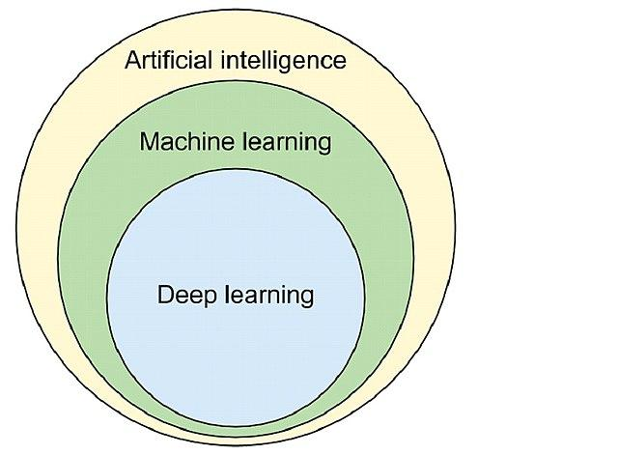 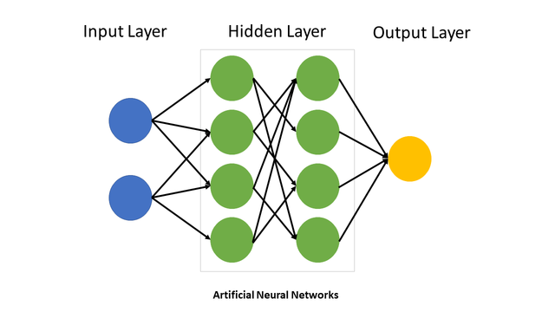

Deep learning suggests how deep the hidden layers are.

In more technical terms , Deep learning is a part of Machine learning based on methods of artificial neural networks with **representation learning**.

| **representation learning -** also called feature learning based on auto selecting features from the dataset i.e. to eliminate manual feature selection. |
| --- |

Also , DL algorithms use multiple layers to progressively extract higher level features from raw input. For e.g. , in image processing , lower layers identify edges , higher layers identify relevant digits, letters or faces.

# Deep Learning Vs Machine Learning

Machine learning learns input / output relations and makes predictions using statistical techniques.

Deep Learning uses a logical structure called neural network to give outputs.

1. Data Dependency

Deep learning requires more data to perform better .

If there is less data , Machine learning wins.

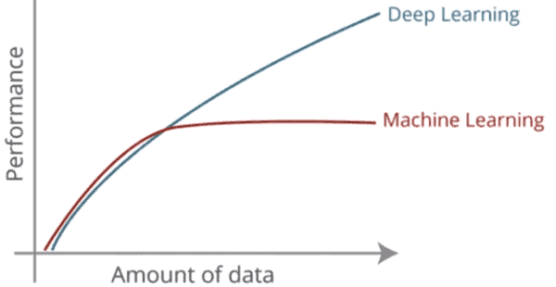

Deep learning is data hungry . More data , better performance.

Machine learning can even interpret results in lesser data .

1. Hardware Dependency

Deep learning has complex matrix multiplications so they require GPU .

ML algorithms can be implemented on CPUs .

1. Training Time

Training time is high in DL , maybe weeks . But prediction time is fast .

Lesser in ML , in minutes . Some algorithms takes time .

1. Feature Selection

Deep learning algorithms automatically extract relevant features from the dataset . (/representation learning)

Machine learning manually selects features .

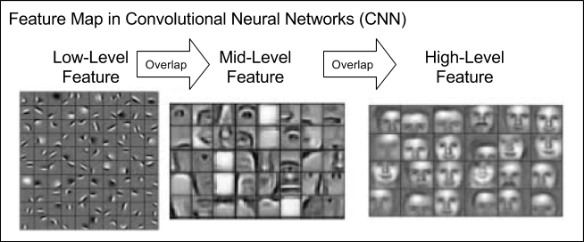

1. Interpretability

I can’t say anything about interpretation of results in Deep learning . It’s like a black box . Cannot explain the results as i didn’t know the inner technicalities.

While in ML , I know the reasons for the results e.g. less weight of any feature or in Decision Tree.

# Why Deep learning getting so famous ?

## Applicability

Applicable in various fields Computer Vision , Speech Recognition , Natural Language Processing , Machine Translation , Bioinformatics , Drug Design , Medical Image Analysis , Climate Science , Material Inspection , Board Games Programmes.

## Performance

State-of-the-art performance . Even human experts in various fields .

E.g. Go - Alphago AI

# 

# Factors Behind Deep learning’s Success

## Hardware

Deep learning is data hungry .

Around 2010 , Smartphone Revolution and Internet Pricing Revolution (Reliance Jio Free Internet) . A great no. of Social media platforms being discovered (TikTok , Snapchat , Telegram , Instagram etc .) . It means data generation vs time shoots exponentially .

Now we have tons of data generated on a daily basis , but this is unlabeled . So these companies Google , Microsoft , Facebook started converting these unlabeled data into labeled ones . But they realised for research purposes these labeled data were publicly issued . So, they make them public datasets which is not an easy to go job , available on google , kaggle etc. `

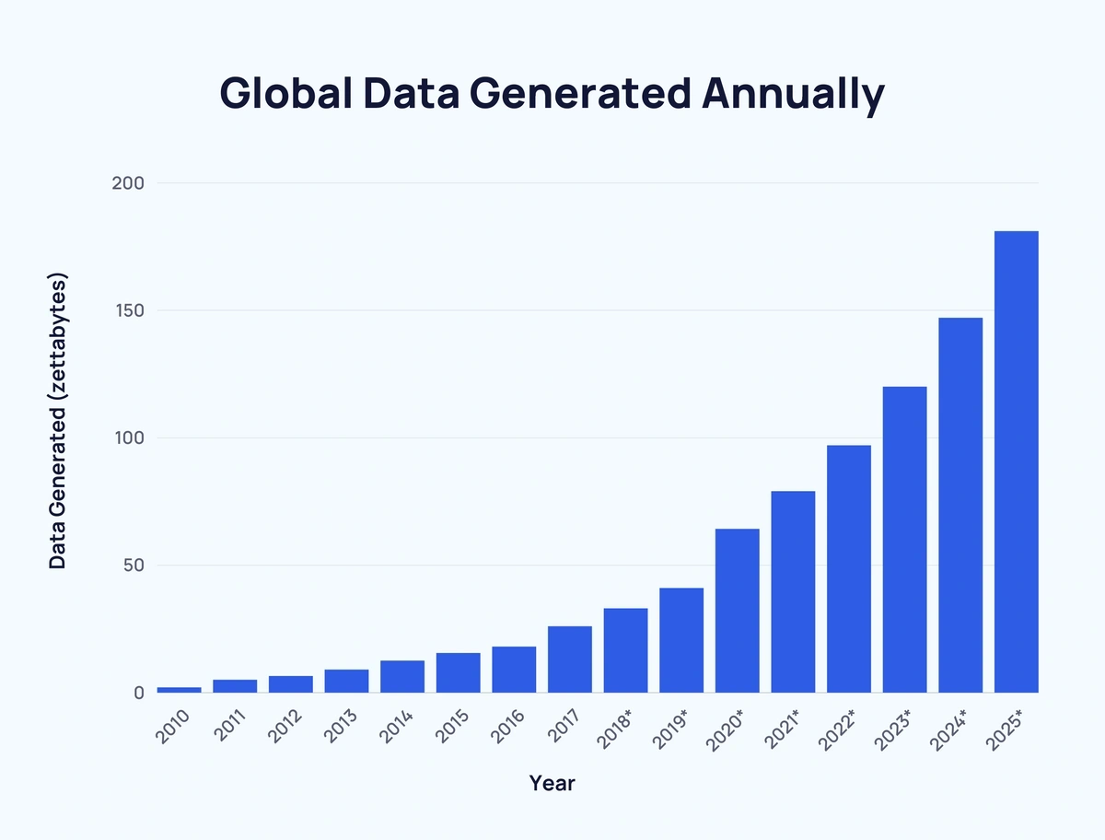

E.g. Image - Microsoft COCO

Video - YouTube 8M (6.1 million videos)

Text - SQuAd Wikipedia (1,50,000)

Audio - google Audioset (20,00,000 sound clips)

Therenow thousands of datasets on various websites.

## Hardware

Moore’s Law - hardware performance improves with prices reducing to half.

Deep learning requires a lot of data and there are matrix operations done on them for processing . Thus a GPU that reduces 10-20 times in place of CPU.

Here comes the concept of Parallel Processing for matrix operations

E.g. FPGA - fast , low power , reprogrammable

ASIC - TPU (Tensor processing unit) (to train a model on deep learning)

Edge TPU , NPU (neural processing unit)

These are basically hardwares to train and run Deep learning models .

## Frameworks / Libraries

As we have Sklearn for ML

Also for DL we have TensorFlow with keras by Google and PyTorch by Facebook .

In 2011 , DistBelief - google

2015 , TensorFlow - google . In between Keras is introduced as an intermediate library because TensorFlow is difficult to use. This is popularly for **Industrial purposes** .

Thereafter introduced T.F 2.0 which comes in with keras .

Meanwhile in 2016 Facebook introduced PyTorch which is basically for **A.I. researchers** .

Also they introduced Caffe2 in 2018 that makes PyTorch completely workable.

Many drop down based GUI Applications were introduced to convert PyTorch code to TensorFlow n viceversa. E.g. AutoML

## Deep Learning Architectures

Depending on the problem there are different types of Neural Networks Architectures .

So figuring out an architecture on the basis of different experiments may take time , effort and money as well .

So architects (/researchers) provided some NN that had been the models trained and they are ready to use . Directly apply them (Transfer learning) .

E.g. for image classification - ResNET archi.

Text classification - BERT

Image segmentation - UNet

Image translation - Pix2Pix

Object detection - YOLO

Speech generation - WaveNET

These are ready to use Architectures developed by Researchers and trained on data . Just download and apply them on the model .

## People / Community

Our researchers (1960’s - till now )